- INTRODUCTION
  - Project Overview :
This project is a visualization tool that focuses on analyzing electric vehicle range and charging infrastructure. The EV Charge and Range Analysis project is a web-based platform that helps users understand important aspects of electric vehicles, such as driving range, charging options, price, and performance. It presents EV data through interactive dashboards and visual stories, making it easy to compare different brands, models, and charging stations across various regions
  - Purpose :
By turning raw EV data into simple and clear visual insights, the platform helps users make better and more informed decisions when choosing an electric vehicle. The web interface is designed to be clean, responsive, and easy to use, so both new and experienced users can navigate it without difficulty.
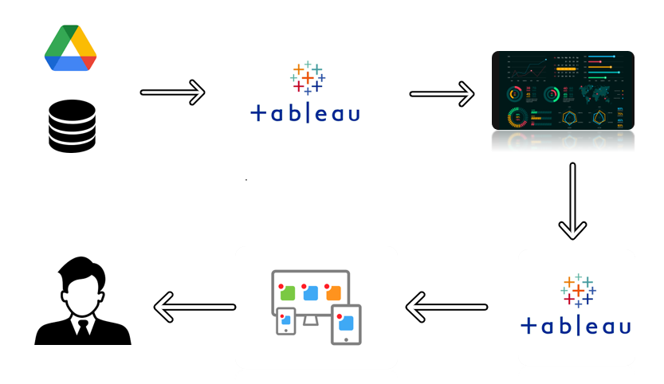

- IDEATION PHASE
  - Problem Statement :
Analysing different data from Multiple sources for Electric cars in India and Globally. We have 4 Different datasets we need to analyse the data and create Dashboard and story that can represent the data and show the Visuals for the data.

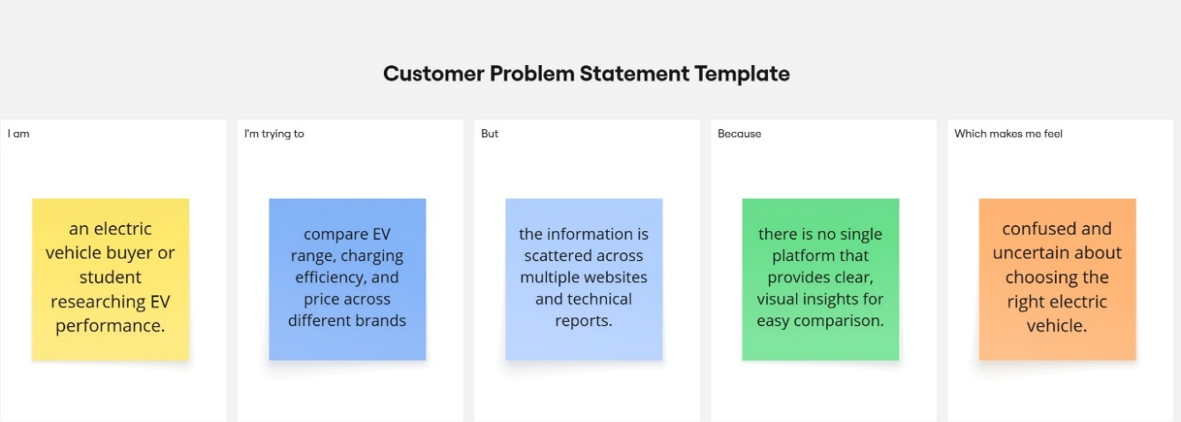

  - Empathy Map Canvas :

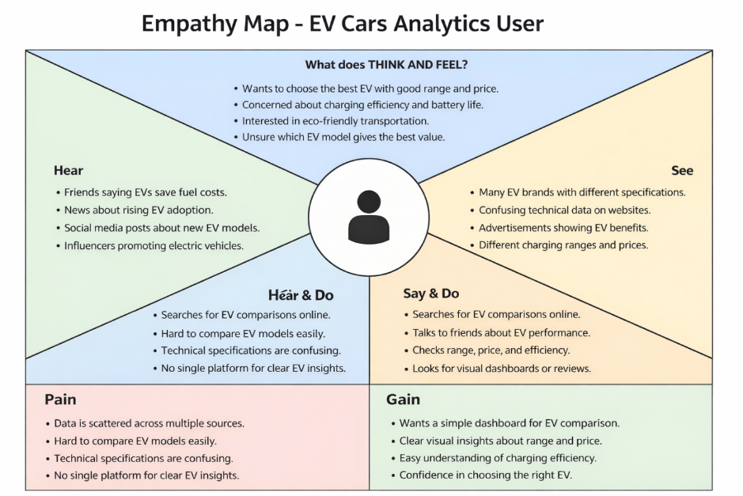
  - Brainstorming :

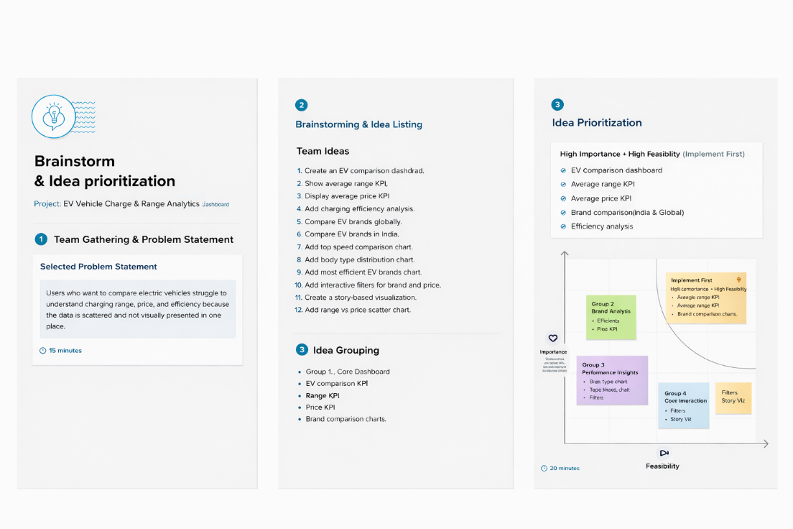

- REQUIREMENT ANALYSIS
  - Customer Journey map :
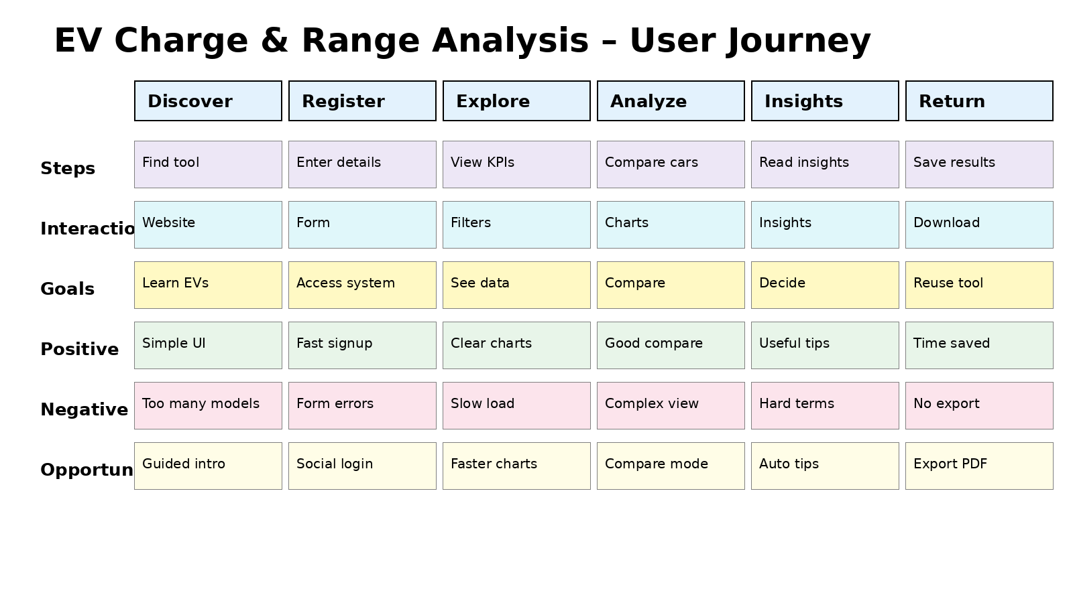
  - Solution Requirement :
Functional Requirements:
Following are the functional requirements of the proposed solution.
FR No. | Functional Requirement (Epic) | Sub Requirement (Story / Sub-Task)
FR-1 | User Registration | Registration through form (name, email, password)  Basic email confirmation after registration
FR-2 | User Confirmation | Login using email and password  Redirect to dashboard after successful login
FR-3 | EV Data Visualization | Display EV dashboards using Tableau  Show charts for range, price, and brand comparison
FR-4 | KPI Display | Show average range KPI  Show average price KPI  Show total EV models KPI
FR-5 | Dashboard Navigation | “Get Started” button opens EV dashboard  Navigation menu for Home, Features, Story, Register, Contact
FR-6 | Contact Form | User can send a message through contact form  Show success notification after submission

Non-functional Requirements:
Following are the non-functional requirements of the proposed solution.
FR No. | Non-Functional Requirement | Description
NFR-1 | Usability | The system should have a simple, responsive, and user-friendly interface accessible on desktop and mobile devices
NFR-2 | Security | User credentials should be stored securely and protected from unauthorized access
NFR-3 | Reliability | The system should display dashboards and data without crashes or errors.
NFR-4 | Performance | Web pages and dashboards should load within a few seconds under normal conditions.
NFR-5 | Availability | The application should be accessible anytime through a web browser.

  - Data Flow Diagram :
A Data Flow Diagram (DFD) is a traditional visual representation of the information flows within a system. A neat and clear DFD can depict the right amount of the system requirement graphically. It shows how data enters and leaves the system, what changes the information, and where data is stored.

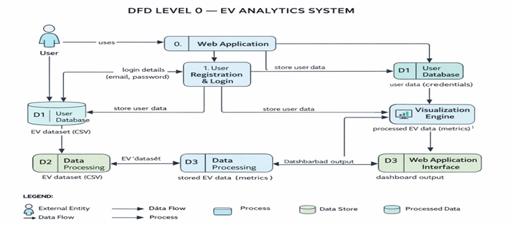

  - Technology Stack :
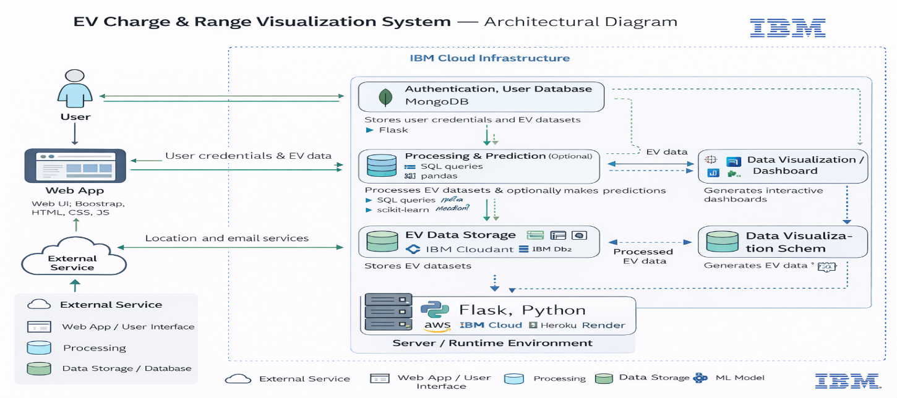

- PROJECT DESIGN

  - Problem Solution Fit :
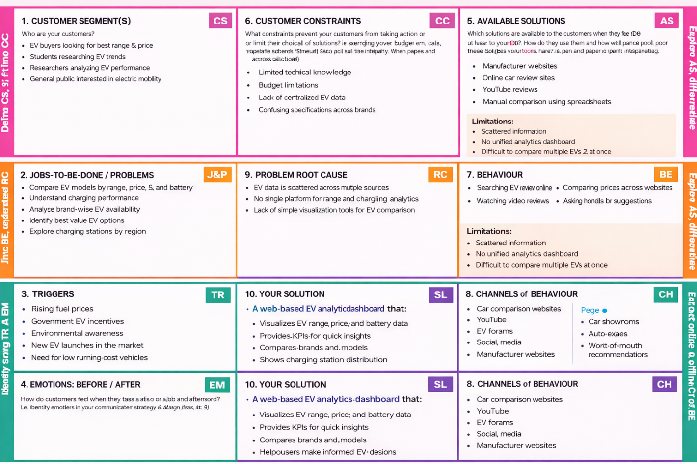

  - Proposed Solution

S.No. | Parameter | Description
 | Problem Statement (Problem to be solved) | There is no centralized and easy-to-use platform for students and researchers to analyze electric vehicle performance, market trends, and environmental impact in a single system. Existing data is scattered across multiple sources, making analysis complex and time-consuming.
 | Idea / Solution description | The proposed solution is a web-based EV Analytics Dashboard that provides interactive visualizations of electric vehicle data such as range, price, battery capacity, charging type, and CO₂ savings. The system uses Flask for backend routing and Tableau Public for advanced data visualization.
 | Novelty / Uniqueness | The uniqueness of this solution lies in the integration of a lightweight Flask web interface with Tableau-powered interactive dashboards and OTP-based user registration. This combination provides both real-time analytics and user engagement in a single academic platform.
 | Social Impact / Customer Satisfaction | This solution promotes awareness about sustainable transportation and helps users understand the benefits of electric vehicles. It enables informed decision-making for students, researchers, and EV enthusiasts, contributing to environmental consciousness.
 | Business Model (Revenue Model) | The platform can be offered as a freemium model where basic analytics are free, while advanced features such as detailed reports, predictive analysis, and enterprise dashboards can be provided as paid services to organizations.

  - Solution Architecture :
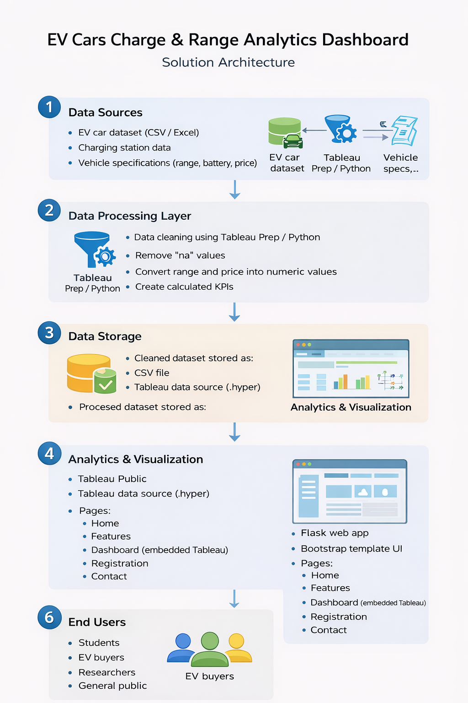
- PROJECT PLANNING & SCHEDULING
  - Project Planning :

Product Backlog, Sprint Schedule, and Estimation
Sprint | Functional Requirement (Epic) | User Story Number | User Story / Task | Story Points | Priority | Team Members
Sprint-1 | Registration | USN-1 | As a user, I can register using email and password. | 2 | High | Team
Sprint-1 | Registration | USN-2 | As a user, I receive confirmation after registration. | 1 | High | Team
Sprint-1 | Login | USN-3 | As a user, I can log in using email and password. | 2 | High | Team
Sprint-1 | Web Setup | USN-4 | Set up Flask project structure with templates and static folders. | 3 | High | Team
Sprint-2 | Data Preparation | USN-5 | Clean EV dataset and remove invalid values. | 3 | High | Team
Sprint-2 | KPI Creation | USN-6 | Create KPIs for average range and average price. | 2 | High | Team
Sprint-2 | Visualization | USN-7 | Create EV range comparison charts. | 3 | High | Team
Sprint-3 | Dashboard | USN-8 | Build Tableau dashboard with multiple sheets. | 5 | High | Team
Sprint-3 | Dashboard | USN-9 | Create EV story visualization. | 3 | Medium | Team
Sprint-3 | Integration | USN-10 | Embed Tableau dashboard into web page. | 3 | High | Team
Sprint-4 | UI Features | USN-11 | Add features, FAQ, and contact sections. | 2 | Medium | Team
Sprint-4 | Contact | USN-12 | Add contact form with success notification. | 2 | Medium | Team
Sprint-4 | Finalization | USN-13 | Test the system and fix UI or data issues. | 3 | High | Team
Sprint-4 | Deployment | USN-14 | Prepare final submission files and documentation. | 2 | High | Team

Project Tracker, Velocity & Burndown Chart:
Sprint | Total Story Points | Duration | Sprint Start Date | Sprint End Date (Planned) | Story Points Completed | Sprint Release Date (Actual)
Sprint-1 | 8 | 6 Days | Day 1 | Day 6 | 8 | Day 6
Sprint-2 | 8 | 6 Days | Day 7 | Day 12 | 8 | Day 12
Sprint-3 | 11 | 6 Days | Day 13 | Day 18 | 11 | Day 18
Sprint-4 | 9 | 6 Days | Day 19 | Day 24 | 9 | Day 24
Velocity:
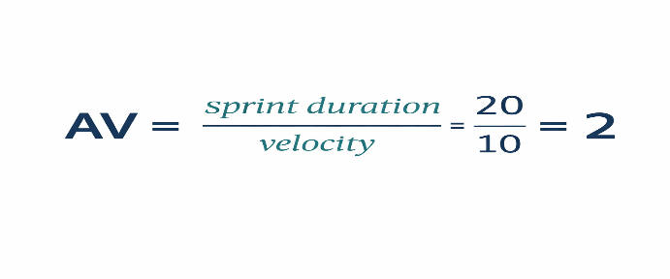
Burndown Chart:
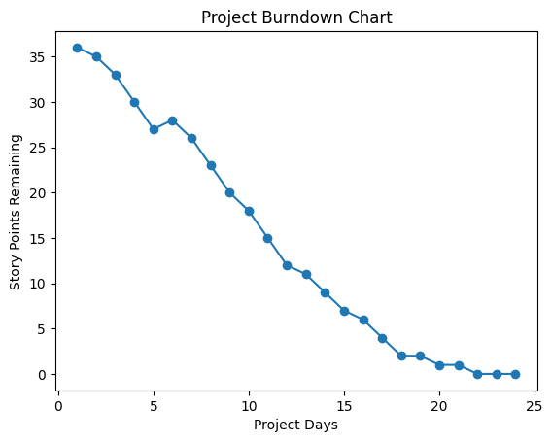
- FUNCTIONAL AND PERFORMANCE TESTING
  - Performance Testing :
S.No. | Parameter | Screenshot / Values
 | Data Rendered | EV car dataset containing: brand, model, price, range, charging type, region, and top speed. Total multiple EV brands and models displayed across dashboard visuals
 | Data Preprocessing | - Removed duplicate entries.  - Handled missing values in price and range fields.  - Standardized brand and model names.  - Converted price units into Lakhs.  - Categorized charging types (AC / DC).
3. | Utilization of Filters | - Brand filter to view specific EV manufacturers.  - Charging type filter (AC / DC).  - Region filter in charging station map.
4. | Calculation fields Used | - Average Range (km).  - Average Price (₹).  - Count of Cars per brand.  - Max Efficiency (Wh/km).  - Top Speed per brand.
5. | Dashboard design | No. of Visualizations: 7  1. Charging Stations Map  2. Count of Cars (Pie Chart)  3. Efficient Brands (Bar Chart)  4. Charging Stations by Region & Type (Stacked Bar)  5. Prices of Cars (Bar Chart)  6. Top Speed of Cars (Bar Chart)  7. Car Types (Treemap)
6 | Story Design | No. of Visualizations: 5  1. Charging Stations in India  2. Charging Stations by Region & Type  3. Price of EV Cars by Brands  4. Different Brands & Number of Models  5. Top Speed of Different Cars

- RESULTS
  - Output Screenshots :
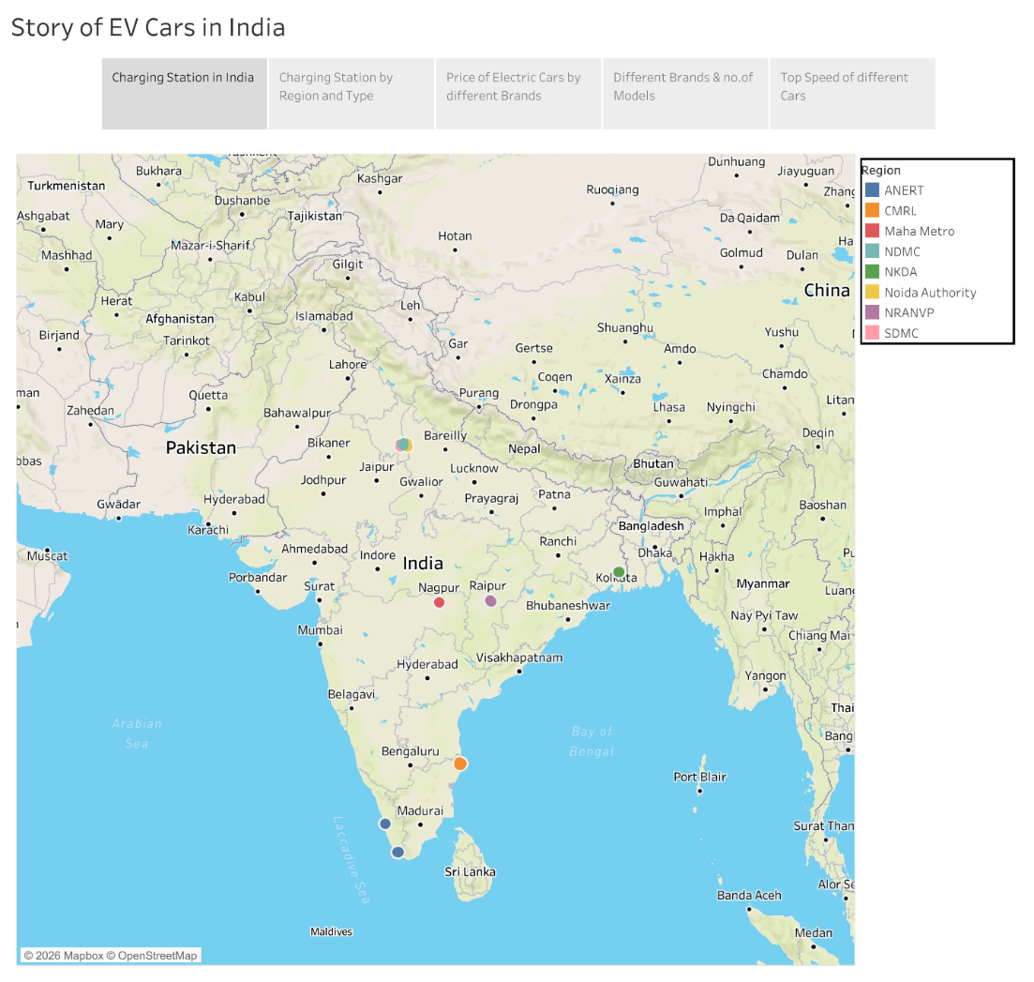
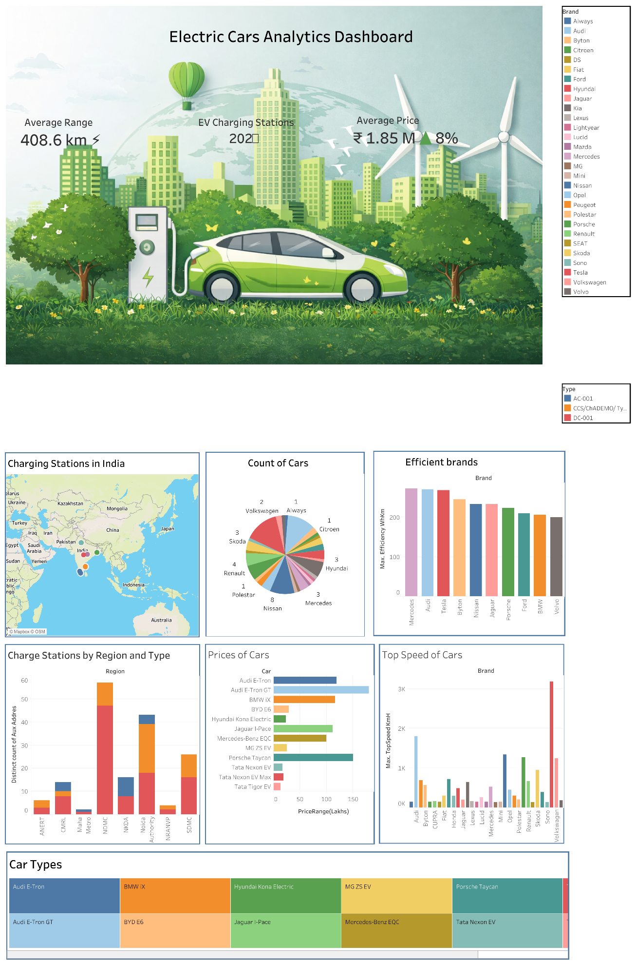

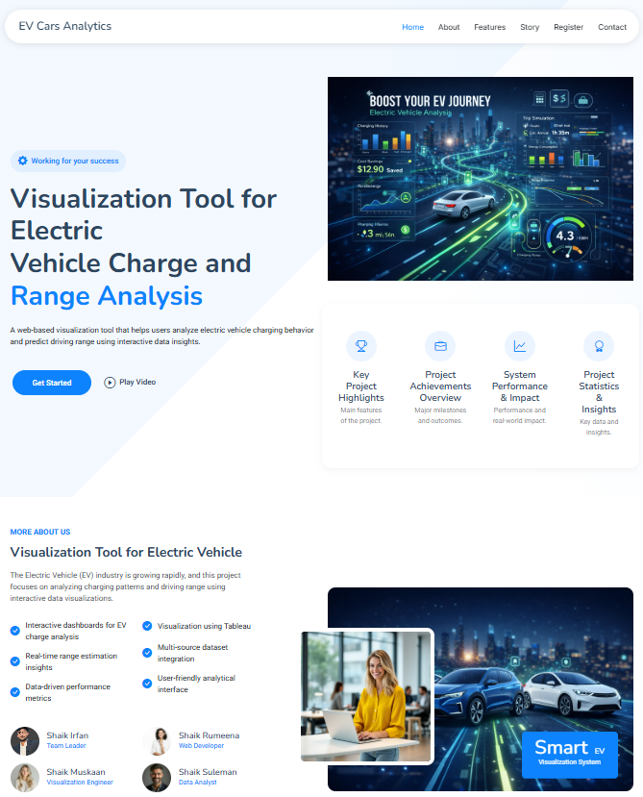
- ADVANTAGES & DISADVANTAGES
Advantages
- Easy EV comparison
- Interactive visualizations
- Charging infrastructure insights
- User-friendly interface
Disadvantages
- Requires internet access
- No real-time charging data

- CONCLUSION
The EV Charge & Range Analysis project successfully demonstrates how data visualization can simplify EV decision-making.The dashboard provides meaningful insights into range, pricing, and charging infrastructure, helping users choose the best electric vehicle.

- FUTURE SCOPE

- Real-time charging data: Integrate live APIs to show real-time availability of charging stations.
- Mobile application: Develop an Android or iOS app for easier access on smartphones.
- AI-based recommendations: Suggest the best EV to users based on budget, range, and usage patterns.
- User accounts and preferences: Allow users to save favorite vehicles and personalized comparisons.
- Expanded dataset: Include more EV models, global charging stations, and updated specifications.
- Route planning feature: Add a tool to plan trips with charging stops based on vehicle range.

- APPENDIX

  - Tableau Public Links:
Dashboard Link :
https://public.tableau.com/shared/TXFB7S72Y?:display_count=n&:origin=viz_share_link
Story Link :
https://public.tableau.com/views/EVCarAnalyticsstory/StoryofEVCarsinIndia?:language=en-US&publish=yes&:sid=&:redirect=auth&:display_count=n&:origin=viz_share_link

Folder Structure:

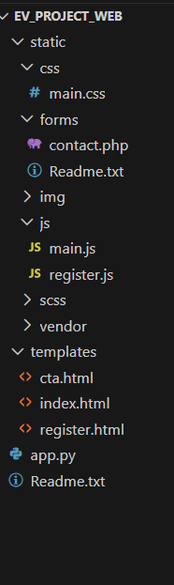

  - Dataset Link:
https://drive.google.com/drive/folders/1Rkzdks6Us1Uq2SRB4nxMAb83jN5bpHll

  - GitHub Repository Link
https://github.com/z-irfan/visualization-tool-for-Electric-Vehicle.git

  - Project Demo Video Link
https://drive.google.com/file/d/1ZeJ_ipbsEzFyI1XHx58RK5mbQnC9togf/view?usp=drivesdk

